JPMC PLACEMENT EXPERIENCE

Name: Sreekesh Iyer | Email: sreekesh.subramanian@gmail.com
Job Offered: Yes | Contact: +91 7977728771
CGPA: 9.35 | CTC: 17.75 LPA (13 + 1.5* + 1.25* + 2**)
Eligibility: 7 CGPA
Company Status: Dream

Timeline:

JPMC RoadShow (Pre-placement Online event - Zoom) | 4, 7 and 8 March 2022
Approximately 4-5 day window was given for attempting Coding Round and Interviews since the emails were sent out in batches.
Coding Round (Hackerrank) | 18-20 March 2022
Interview Round (HireVue) | 26 March - 1 April 2022
Shortlist Result | 09 May 2022
CodeForGood Bootcamps (GitHub, Office Hours, Presentation Skills) - Zoom | 24-26 May 2022 (1 hr sessions every day)
Slack Invites | 25 May 2022
BeMyApp Registration Invites | 08 June 2022
JPMC CodeForGood Hackathon | 11 - 12 June 2022
Final Shortlist Result | 19 July 2022
Post Selection
Location Preference Form | 12 September 2022
Location Confirmation (from the company) | 05 May 2023
Receiving the Offer Letter | 12 May 2023
Joining Date | 07 August 2023

JPMC RoadShow Event

Call it pre-placement or an introductory talk, this was a Zoom rebroadcast of a recorded conversation among different employees at JPMC all over India as they talked about what they did, what they were planning to work on, the different opportunities they were offered at the company, the work culture, etc. They also briefly discussed their experience at CFG and also talked about the internal perspective of actually managing and conducting a Hackathon.
Dates: 4,7 and 8 March 2022

Important things to note:
While the event might not sound as interesting at the beginning, these talks always give you an idea of what the company expects from their employees, what it is like to work in that company and a lot more. This is what I eventually ended up using as content for my video interview.

Coding Round | Hackerrank

I got an email from JP Morgan’s Hackerrank mailer on 18th March 2022 with the Test link on my registered email address (personal).

Questions

- Coding Friends
The problem reads:
“Can Kelly solve enough code challenges to catch up with Sam?
Sam and Kelly are programming buddies. Kelly resolves to practice more as Sam is ahead initially. They each solve some problems daily. Find the minimum number of days for Kelly to have solved more problems than Sam. If Kelly cannot surpass return -1.“
It’s just a comparison of two entities and how long it’d take for one to surpass the other based on the daily increments and an initial difference. Just one while loop is all it takes. The link takes you to the same problem.
Solution: https://www.hackerrank.com/challenges/coding-friends/problem
- Selling Products
The problem reads:
“A man sells fake identities and has a collection of ‘N’ IDs to sell. How does he ensure he has the least number of unique IDs left after selling ‘M’ IDs?“
The problem is to find “The Minimum number of distinct elements after removing m items from an Array”
Solution: https://www.geeksforgeeks.org/minimum-number-of-distinct-elements-after-removing-m-items/
Important things to note:

- Your camera has to be on at all times.
- Hackerrank has strict plagiarism detection software that uses M.O.S.S, which can identify whether your code is original or not.

Interview Round

Platform: HireVue

I got an email from interviews@hirevue.com on behalf of JP Morgan Chase on 28th March 2022 that stated that the video interview was the next step of the recruitment process. The candidates shortlisted from the coding round received these emails.

Questions
- Tell us about an experience that you would describe as a learning experience. Tell us about the problem and the outcome.
- Tell us about the specific career goals that you have set for yourself.
My Answers ( as far as I can remember)
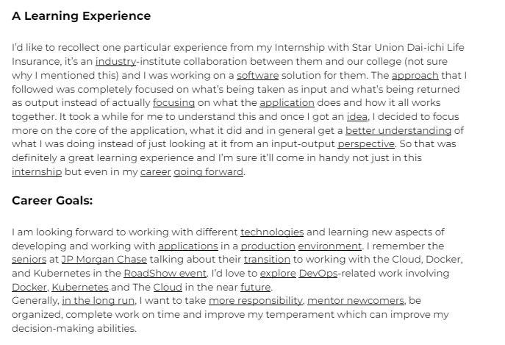

Important things to note:

- This is your only opportunity to interact with the recruiter and make an impression before CFG. Make sure you’re wearing formal clothes, ‘a suit or blazer, dress pants and a tie, pant-suit or dress and jacket’ is what they recommend.
- Sit in a well-lit environment and make sure you can be seen and heard clearly. You’ll get all the required options to test these things out.
- You can answer up to 3 practice questions to understand how the platform works. The experience will be the same as the actual questions, so you can use these questions to warm yourself up.
- You only get two attempts to answer a question. You get 30 seconds each to PREPARE for a question, i.e. note something down or think about the answer. This preparation time is only available for the first take. Once you try to attempt a question for the second time, you get only 3 seconds before the recording starts.
- Look into the camera as you speak. Try to smile (don’t force yourself, though). Be loud and clear about every point you make. Do not hesitate. Practice tongue twisters to avoid muffled words (if you have that problem).
- Don’t over-script your answers. Try to be genuine and honest, or at least try to make your answers sound natural.

Shortlisting after the Interview Round
It’s a long anxious wait after clicking that final Submit button on Hirevue. A month after the video submission, I got an email from the staff placement coordinator with a Google Sheet comprising the list of the shortlisted candidates. This was on 9th May 2022.

Total Shortlisted Candidates: 48
INFT - 23
CMPN - 17
EXTC - 4
ETRX - 2
MCA - 2

The eligibility criteria are unknown, the process is internal. if you are not shortlisted here, don’t be dejected. You just didn’t go through the algorithm.
Keywords that seemed to work: Experience, Internship, Mentor, Senior, Connect, Growth, Efforts, Approach, Focus, Understanding, Career, Guidance, Application, Learning, Future

Code For Good 2022

Timeline

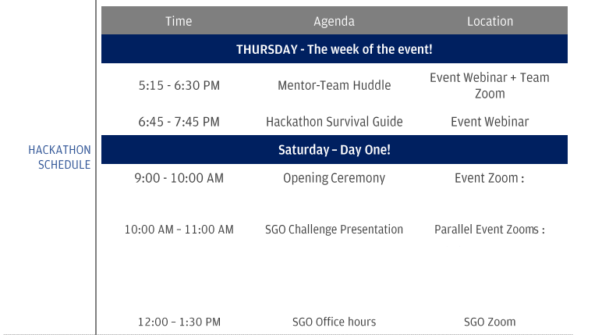
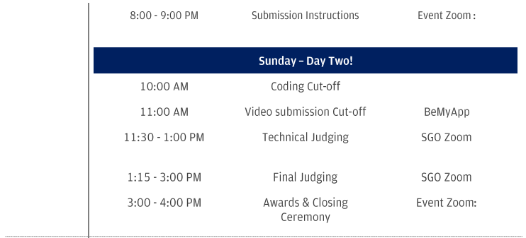
- SGO Assigned - Center for Gender and Politics
- Team No. 91
- Team Size - 8 (later reduced to 4, since people dropped out)
- No. of Mentors -2

Result: Winners
Read more about my CodeForGood Experience here and on my blog.

Important things to note:

- Firstly, accept this for a fact that people WILL drop out. If your team of 7 or 8 makes it to the end, awesome, but that’s not always the scenario. There could be multiple reasons for one or more of your teammates backing out from the event. In this situation, please do not yell at them, there might be some unforeseeable circumstances on their end, that we can do nothing about.
If your team has less than 5 people at the start of the Hackathon, inform the organisers and they’ll make some arrangements.
If you have to drop out of the event for some reason, inform your teammates, mentors and organizers as early as possible.
- Most problems won’t require you to use AI or ML, since the SGOs generally require web-based solutions. Hence, you should ideally learn a few frameworks that you might use in the hack.
- Learning a few popular tech stacks like MERN can come in handy since that’s what a lot of teams end up using. I’d recommend learning React, and Django and working with Databases like MySQL and MongoDB.
- If you are familiar with React fundamentals and are confident about making APIs, working with databases, etc. you can start looking into the Jamstack. It’s using frameworks along with microservices that can easily set up your application. For instance, we used Next.js and Strapi as our tech stack. This meant that we did not have to write any additional code for the server side and databases. Similarly, you can make use of services like Firebase, Supabase, etc. which can save you a lot of time.
- Have code templates ready before time, do not spend too much time setting up boilerplate code and the integration between the client and server. Things like these along with authentication are mostly the same regardless of the application you’re making, so try to get these things done before the start of the hackathon so that you can just build on this when you start working on the solution.
- Work on separate branches on GitHub. A GitHub repository will be provided to you 2 days before the event.
- You’ll also be provided with an EC2 instance that you can connect to, using their proprietary VPN, the credentials to which, will also be provided.
If you have an AWS account with Free Tier I wouldn’t recommend doing this, since the setup is a little tedious and you do not have control over the instance. You can simply create your EC2 instance and work on it. You can have the instance running for 24 hrs and still won’t be charged.
- Be comfortable speaking with your mentors, they are just like your friends and they want to know you. They won’t be evaluating you all the time. When you’re having a one-on-one conversation with the mentors, be honest when you answer their questions. They’re experienced people and can easily catch your bluff.
- Get your code ready by 8 AM, since the GitHub repositories will be locked after 9 AM. While you are coding, prepare for the video submission side-by-side. I suggest making a small 7-8 slide presentation that explains your approach to the problem. You can explain this presentation and then demonstrate your application. All of this has to be completed in under 7 minutes. This needs to be submitted by 11 AM.
- You can play the recorded video submission in the Technical Judging round later or you can also optionally present your work live. The same applies to the Final Round.
- After presenting your work, the judges will ask you some questions about the application. It’s best if you’re honest about what you’ve done. It’s crucial how you thought about the solution and how feasible it is and how beneficial it can be in the long run for the SGO. It’s understandable if you couldn’t achieve everything in just 24 hours, but please do not lie to the judges about any possible flaws. If something is static or broken, let them know if they ask you.
- 2 teams qualify for the Final Judging round for each SGO Problem Statement.
- Lastly, please enjoy the event. You've been put in a team with a bunch of random people from different parts of the country, CONNECT WITH THEM. Bond with them, know what they’re doing, which colleges they belong to, their plans, etc. It’s a team event. If you compete with each other, it’ll be tough for you to bring something useful to the SGO, which is pretty much the end goal of this hack.

Whether you get an offer letter or not is not in your hands, but what you do have in your hands is the next 24 hours and a problem to solve. Simply work on that collectively and the result will take care of itself.

Final Shortlist

It takes more than a month for the company to announce the final shortlist across all colleges. Sometimes, some colleges/universities announce the results before yours, so it’s recommended that you keep in touch with your faculty SPOC for JPMC and the student coordinators for the latest updates.

Our results were announced on 19 July 2022. 41 out of 48 participants in CFG were selected.

My final suggestions

- If you have attempted CFG and had a decent time at the hack and a good talk with the mentor, you should be fine. But JPMC results are very unpredictable.
- What I’d recommend is to start preparing for your aptitude rounds (something that almost all other companies conduct) by learning to solve aptitude problems on websites like indiabix.
- Lastly, don’t stress too much and do not rely too much on these results. As I mentioned, you can’t predict them. Be prepared to sit for other companies if this doesn’t work out, something I’d also advise you to do for any other company as well.

All the best :)

* | 13L Fixed Base Pay  - 1.5L One-Time Sign-On (Joining Bonus)  - 1.25L Relocation Lump Sum if applicable
** | - 2L Incentive Bonus, subject to company, business and individual performance
SGO | Social Good Organization

Post Selection Thoughts

Not very relevant to this document, but certainly something that you might want to know.

The final shortlist comes in July, which is very early in your 4th Year. If you’re selected, congratulations, you’re bound to join an amazing company for your first job.

Location Preference Form

The company offers you a full-time internship for 5 months (Feb-May) which you cannot accept if you’re in Engineering because Mumbai University has a curriculum in Sem 8 for which you need to pass the 75% attendance criteria and the internship is in-office full-time. This might change if the college gets autonomy or the University decides to change its rules, in which case you may have a free 8th Sem. Otherwise, tough luck.
PS: No matter how hard you try, you won’t be allowed to go for the internship. We’ve tried it, you don’t have to. Don’t waste your time, accept it and move on. Accept the fact, not the internship offer.

With that same internship form, however, there’s a location preference section where you have to choose your top two locations. It’s generally two out of Mumbai, Bengaluru and Hyderabad. Keep in mind that you may not get your first choice, or even the second for that matter.

Getting your Offer

It takes MONTHS to get any further communication from the company and it sometimes got me thinking about whether I even have a job. Having said that, they’re very professional about what they do and they WILL take care of the onboarding, don’t worry about it too much.

What you can worry about is how you’re going to spend the rest of your college life.
You can take a break for a good month or two, after which you can come back into the zone and focus on some of these things:
- Maintain a decent CGPA
- If you’re good at competitive coding (Leetcode, Codechef, etc.), don’t stop doing it.
- Help your juniors out, they’re going through a critical time right now, and they’ll need to know what they should focus on.
- Don’t lose touch with coding and development.

Post Accepting Offer Procedure

Read the offer letter carefully before accepting it. It’s a 15-20 page document, but please, please read it.

The onboarding process is as long as your Engineering, but please be patient with it. Instead of trying to get done with it quickly, try to do it right. Don’t make silly mistakes, if you have any doubts, ask the concerned people.

ALERT: Your location will NOT be final until say, 1 month before joining. Yes, your offer letter clearly mentions a location, but you might be at a receiving end of an email on a random Monday morning with the subject line - “Update in Location - City A to City B”.

So please do not book your tickets or arrange accommodation too early. The relocation lumpsum is sufficient enough to cover your moving expenses even if it’s at a shorter notice. I’d suggest booking only the train tickets (if you are travelling by train) beforehand because they get booked very quickly and you get a fair amount of refund if you cancel them.

Documents required: Aadhaar, PAN, Passport (optional), Covid Vaccination Certificates, HDFC Bank account

